SIMATS ENGINEERING (SAVEETHA SCHOOL OF ENGINEERING)
Department of Computer Science and Engineering
CO2_AT1 — CHART CONSTRUCTION TEST

Course Code: | DSA06 | Course Title: | Data Handling and Visualization
CO Assessed: | CO2 – Construction (BL3) | Assessment: | Assessment Tool 1 – Chart Construction
Weightage: | 20% of CIA | Total Marks: | 25 (5 Questions × 5 Marks)
CO2 Statement: | Apply appropriate chart construction techniques — correct chart type, axes, scales, and calculations — to accurately represent given data.(BL3)
Student Name: | P. SIDDARDHA | Reg. No.: | 192424271
Section / Batch: | AIDS/2024 | Date: | 30-07-26

Code of Conduct
I _P. SIDDARDHA (192424271) (Name / Reg No) certify that this submission is my original work and that I have adhered to the guidelines specified for this assessment. I understand that any violation of academic integrity rules will result in disciplinary action.

Signature of the Student: __P. SIDDARDHA__

Instructions
- This test contains 5 questions, each carrying 5 marks. Total: 25 Marks.
- No negative marking. Unanswered questions carry zero marks.
- No calculators or electronic devices permitted.
- Duration: 75 minutes.
- Graph paper or a ruler is recommended for accurate, to-scale drawing.
- Show all calculations (e.g., percentages, angles, bin ranges, five-number summaries) as part of your answer.
- Every chart must include a title, correctly labeled axes, and a legend where applicable.

Annexure A – CHART CONSTRUCTION

Problem 15 – Radar (Spider) Chart (5 Marks)
Question
A laptop is rated on five attributes (scale 1–10):
- Battery = 8
- Speed = 7
- Display = 9
- Price = 6
- Weight = 7
Construct a radar chart with five axes, one for each attribute, plotting the laptop's ratings as a single connected polygon.

Aim
To construct a Radar (Spider) Chart that compares the laptop's performance across five different attributes using a common rating scale.

Dataset
Attribute | Rating
Battery | 8
Speed | 7
Display | 9
Price | 6
Weight | 7

Calculations
The laptop ratings are plotted directly on a scale of 1 to 10.
Attribute | Rating
Battery | 8
Speed | 7
Display | 9
Price | 6
Weight | 7
Each attribute forms one axis of the radar chart, and the plotted points are connected to create a single polygon representing the laptop's overall performance.

Answer
A Radar (Spider) Chart is the most appropriate chart because it compares multiple performance attributes of a single object on the same scale. Each attribute is represented by an individual axis radiating from the centre, and the ratings are connected to form a polygon.
The radar chart shows that the laptop performs best in Display (9), followed by Battery (8). Both Speed and Weight have ratings of 7, indicating good performance, while Price (6) has the lowest rating. The polygon provides a quick visual summary of the laptop's strengths and weaknesses.

Result
The Radar Chart clearly compares all five laptop attributes simultaneously. It shows that the laptop has strong display quality and battery performance, while price receives the lowest rating.
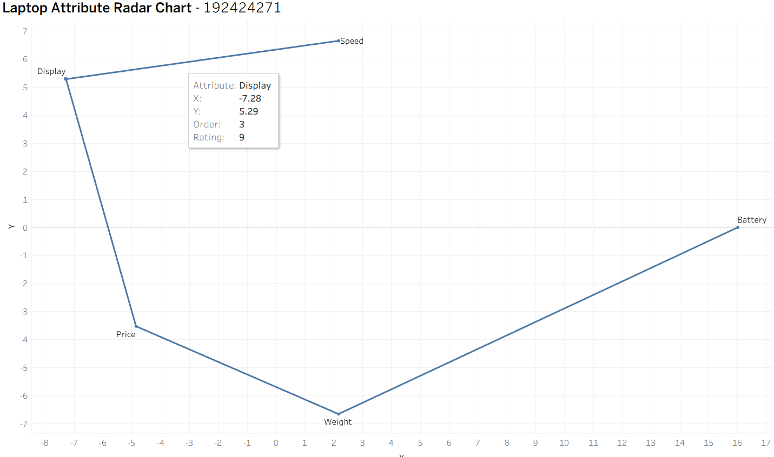
Conclusion
The Radar Chart is an effective visualization for comparing multiple attributes measured on the same scale. It highlights the laptop's overall performance profile and makes it easy to identify strengths and weaker areas. The chart is accurately constructed with five axes, correctly plotted ratings, and a connected polygon, satisfying the chart construction requirements.

Problem 16 – Heatmap (5 Marks)
Question
Website visits by day and time slot:
- Morning: Mon = 120, Tue = 150, Wed = 100, Thu = 180
- Afternoon: Mon = 200, Tue = 220, Wed = 190, Thu = 240
- Evening: Mon = 90, Tue = 100, Wed = 80, Thu = 110
Construct a heatmap for this 3 × 4 grid, choosing an appropriate sequential colour scale and shading each cell according to its value.

Aim
To construct a Heatmap that represents website visits across different days and time slots using a sequential colour scale to highlight variations in visit counts.

Dataset
Time Slot | Monday | Tuesday | Wednesday | Thursday
Morning | 120 | 150 | 100 | 180
Afternoon | 200 | 220 | 190 | 240
Evening | 90 | 100 | 80 | 110

Calculations
A Sequential Colour Scale is used because the data consists of numerical values representing website visits.
Visit Range | Colour Intensity
80–100 | Light Blue
101–150 | Medium Blue
151–200 | Dark Blue
201–240 | Darkest Blue
- Minimum Visits = 80
- Maximum Visits = 240
The colour intensity increases as the number of website visits increases.

Answer
A Heatmap is the most suitable visualization because it represents numerical values using colour intensity within a grid structure. The rows represent Time Slots, while the columns represent Days of the Week.
A sequential blue colour palette is selected since all values are positive and increase from low to high. Lighter shades indicate fewer website visits, while darker shades indicate higher website visits.
The heatmap clearly shows that Thursday Afternoon (240 visits) has the highest number of visits and therefore appears with the darkest shade. Wednesday Evening (80 visits) has the lowest number of visits and appears with the lightest shade. This colour variation enables quick comparison across all time slots and days.

Result
The Heatmap successfully visualizes website visit patterns across different days and time slots. The colour intensity makes it easy to identify periods of high and low website traffic without examining every numerical value individually.
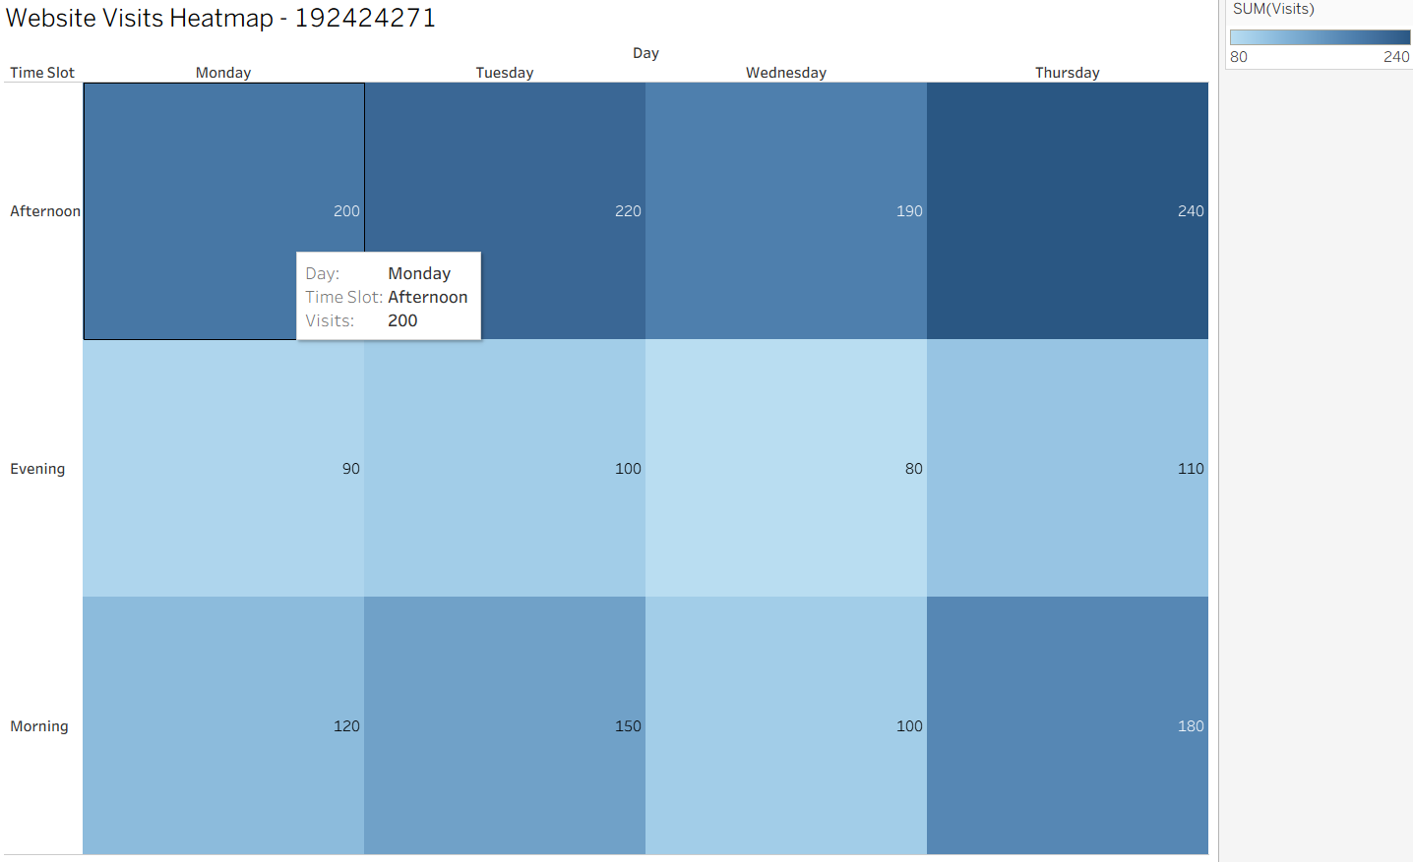

Conclusion
The Heatmap is an effective visualization for displaying numerical values in a matrix format. The sequential colour scale clearly represents differences in website visits, allowing users to quickly identify trends, peak activity periods, and lower traffic periods. The chart is accurately constructed with labelled rows, columns, appropriate colour scaling, and correctly shaded cells, satisfying the chart construction requirements.

Problem 17 – Cartesian Coordinate Plotting (5 Marks)
Question
Five coordinate points are given:
- (1,3)
- (2,5)
- (3,4)
- (4,8)
- (5,6)
Construct a Cartesian coordinate plot of these five points with correctly scaled and labelled X and Y axes.

Aim
To construct a Cartesian Coordinate Plot that accurately represents the given coordinate points using correctly scaled and labelled X and Y axes.

Dataset
X Coordinate | Y Coordinate
1 | 3
2 | 5
3 | 4
4 | 8
5 | 6

Calculations
The given coordinate pairs are plotted directly on the Cartesian plane.
Point | Coordinates
P1 | (1,3)
P2 | (2,5)
P3 | (3,4)
P4 | (4,8)
P5 | (5,6)
Axis Scale
- X-axis: 1 to 5
- Y-axis: 3 to 8
Each point is plotted according to its respective X and Y coordinate.

Answer
A Scatter Plot (Cartesian Coordinate Plot) is the most appropriate chart for representing coordinate pairs because it accurately displays the relationship between two numerical variables.
The X-axis represents the X coordinates, while the Y-axis represents the Y coordinates. Each point is plotted at its exact location on the Cartesian plane, ensuring accurate representation of the dataset.
From the plotted graph, the highest point is (4,8), indicating the maximum Y-value, while the lowest point is (1,3). The scatter plot clearly shows the distribution of all five coordinate points and allows easy comparison of their positions.

Result
The Cartesian Coordinate Plot successfully represents all five coordinate points with correctly scaled and labelled axes. Each point is plotted accurately according to the given coordinates, making the distribution of values easy to interpret.
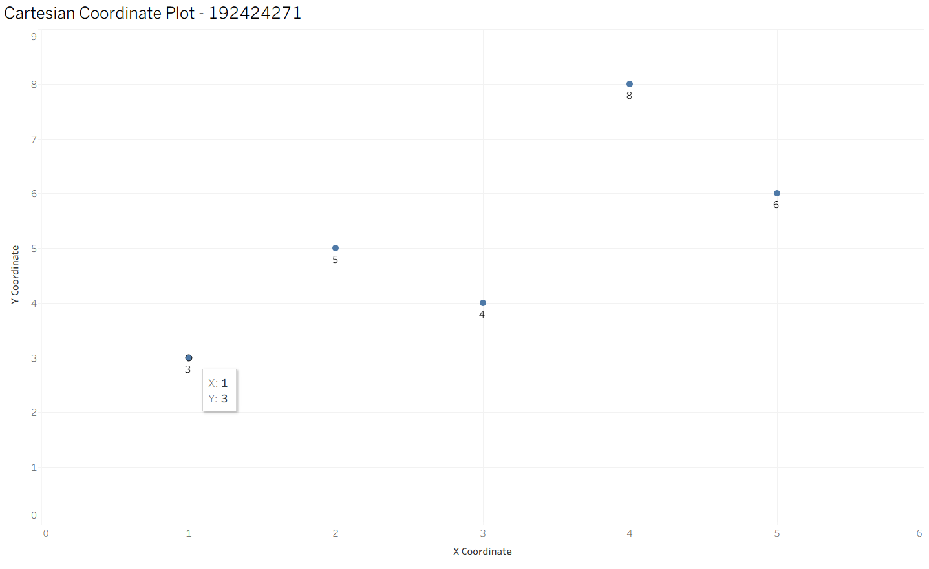
Conclusion
The Cartesian Coordinate Plot is an effective visualization for displaying coordinate data because it accurately represents the position of each point on the X and Y axes. Proper axis scaling, labelling, and accurate plotting ensure that the visualization clearly communicates the relationship between the given coordinates, satisfying the chart construction requirements.

Problem 18 – Logarithmic Axis Construction (5 Marks)
Question
Company revenue over five years:
- Year 1 = $10,000
- Year 2 = $50,000
- Year 3 = $250,000
- Year 4 = $1,200,000
- Year 5 = $8,000,000
Construct a bar or line chart using a logarithmic Y-axis. Show the axis tick values selected and explain why a linear axis would be unsuitable.

Aim
To construct a line chart using a logarithmic Y-axis to accurately represent company revenue that increases exponentially over five years.

Dataset
Year | Revenue ($)
Year 1 | 10,000
Year 2 | 50,000
Year 3 | 250,000
Year 4 | 1,200,000
Year 5 | 8,000,000

Calculations
Selected Logarithmic Axis Tick Values
The logarithmic Y-axis uses increasing powers of 10 (and intermediate values automatically generated by Tableau), such as:
- 10
- 20
- 50
- 100
- 200
- 500
- 1,000
- 2,000
- 5,000
- 10,000
- 20,000
- 50,000
- 100,000
- 200,000
- 500,000
- 1,000,000
- 2,000,000
- 5,000,000
- 10,000,000
These logarithmic intervals allow both small and large revenue values to be displayed clearly on the same chart.

Answer
A Line Chart with a Logarithmic Y-axis is the most appropriate visualization because the revenue values increase by very large amounts over time. A logarithmic scale compresses large values while preserving the growth trend, making all data points visible and easy to compare.
The X-axis represents the five years, while the Y-axis represents company revenue using a logarithmic scale. The plotted line clearly shows the continuous increase in revenue from $10,000 in Year 1 to $8,000,000 in Year 5.
A linear Y-axis would be unsuitable because the revenue values differ by several orders of magnitude. The smaller values (such as $10,000 and $50,000) would appear extremely close to the X-axis, making them difficult to distinguish. A logarithmic scale distributes the values more evenly, allowing both small and large revenues to be interpreted accurately.

Result
The logarithmic line chart clearly represents the exponential growth in company revenue over five years. The logarithmic scale improves readability by displaying both smaller and larger revenue values proportionally.
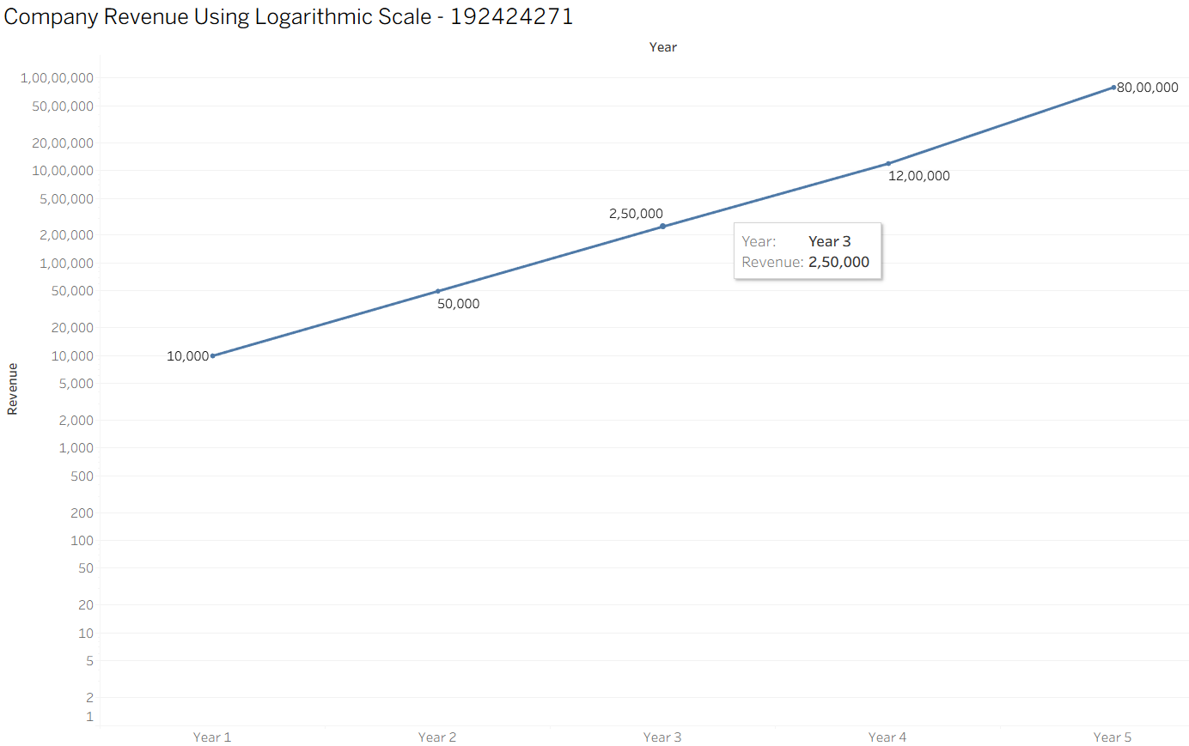
Conclusion
A logarithmic Y-axis is the most suitable choice for datasets containing large differences in numerical values. It preserves the overall growth pattern while improving readability and comparison across all years. The chart is accurately constructed with a correctly labelled logarithmic axis, appropriate scaling, and correctly plotted revenue values, satisfying the chart construction requirements

Problem 19 – Polar Coordinates (Pie Chart) (5 Marks)
Question
Time allocation in a 24-hour day:
- Sleep = 8 hours
- Work = 8 hours
- Leisure = 4 hours
- Chores = 2 hours
- Commute = 2 hours
Construct a Pie Chart (Polar Coordinates) showing this time allocation. Calculate and label the angle for each sector.

Aim
To construct a Pie Chart using polar coordinates that accurately represents the distribution of daily time allocation across different activities.

Dataset
Activity | Hours
Sleep | 8
Work | 8
Leisure | 4
Chores | 2
Commute | 2

Calculations
Total Hours = 24
Formula for Sector Angle:
$$\text{Angle}=\left(\frac{\text{Hours}}{24}\right)×{360}^{∘}$$
Activity | Hours | Calculation | Angle
Sleep | 8 | (8 ÷ 24) × 360 | 120°
Work | 8 | (8 ÷ 24) × 360 | 120°
Leisure | 4 | (4 ÷ 24) × 360 | 60°
Chores | 2 | (2 ÷ 24) × 360 | 30°
Commute | 2 | (2 ÷ 24) × 360 | 30°

Verification:
120° + 120° + 60° + 30° + 30° = 360° ✓

Answer
A Pie Chart is the most appropriate visualization because it represents how a whole (24 hours) is divided into different categories. Each slice corresponds to the proportion of time allocated to a specific daily activity.
The size of each slice is determined by its calculated central angle. Sleep and Work each occupy 120°, making them the largest portions of the pie chart because they each account for one-third of the day. Leisure occupies 60°, while Chores and Commute each occupy 30°, making them the smallest portions.
Using different colours for each activity and appropriate labels improves readability and enables quick comparison of time allocation across activities.

Result
The Pie Chart clearly represents the distribution of time across the five daily activities. It shows that Sleep and Work consume the largest share of the day, while Chores and Commute require the least amount of time.
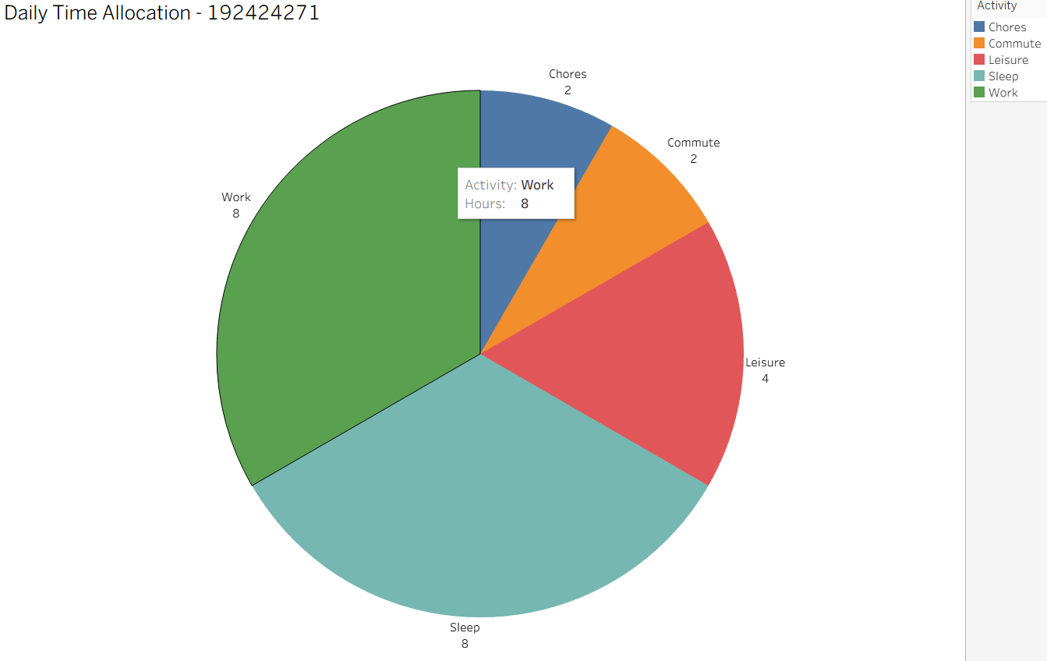
Conclusion
The Pie Chart effectively represents daily time allocation using polar coordinates. The calculated sector angles accurately reflect the proportion of time spent on each activity, ensuring that the chart is mathematically correct and easy to interpret. The chart includes appropriate labels, colours, and proportional sectors, satisfying the chart construction requirements and demonstrating accurate application of pie chart principles

Rubrics for Calculation ASSESSMENT RUBRIC
AT1 — Chart Construction Test
CO2 · BT3: Apply ·
This rubric is used to assess student responses to the CO2-AT1 Chart Construction Test, in which students are given a small dataset and must construct an accurate, correctly labeled chart of a specified type.

Criteria | Weightage | Level 4 – Exemplary | Level 3 – Proficient | Level 2 – Developing | Level 1 – Beginning
Understanding of Concepts | 25% | Demonstrates thorough, accurate understanding of the correct chart type, and the axes, scale, and elements required to construct it for the given data. | Good understanding of the required chart type and construction elements, with only minor gaps. | Basic understanding of chart construction, but with some misconceptions about the correct chart type, axes, or scale. | Poor understanding of core construction concepts; selects a chart type or elements fundamentally unsuited to the data.
Explanation | 25% | Shows detailed, clearly worked calculations (e.g., angles, bin ranges, five-number summary) and explains each construction step. | Shows clear calculations and construction steps, with adequate explanation for most parts. | Calculations or construction steps are shown but incomplete, or explanations are superficial. | Little or no working shown; calculations and construction steps are missing or unexplained.
Application | 20% | Effectively applies chart construction techniques to produce a complete, accurate chart correctly matched to the data. | Applies construction techniques to produce a correct chart, with only minor errors. | Limited application of construction techniques; the chart partially represents the data but has notable errors. | Fails to apply appropriate construction techniques; the chart does not correctly represent the data.
Organization | 15% | The chart is neatly and logically constructed, with a title, correctly labeled axes, a legend where applicable, and elements in a clear order. | The chart is well organized, with only minor issues in labeling, legend, or layout. | Basic construction; required elements (title, axes, legend) are present but poorly arranged or partly missing. | Poorly constructed; the chart is missing key elements such as a title, axis labels, or a legend.
Accuracy | 10% | The chart is completely accurate — all values, proportions, scales, and calculations correctly match the given data. | Mostly accurate, with only minor omissions or a small error in one value or calculation. | Partially correct; some plotted values, proportions, or calculations are missing or incorrect. | Largely inaccurate; major errors in plotted values, proportions, or calculations relative to the given data.

Scoring Guide
For each criterion, award a performance level (1–4) based on the descriptors above. Multiply the level achieved (as a percentage of 4, i.e., Level 4 = 100%, Level 3 = 75%, Level 2 = 50%, Level 1 = 25%) by the criterion's weightage, then sum across all five criteria to obtain the total score out of 100%.

Faculty In-charge | Course Coordinator | Head of Department
Signature: _______________ | Signature: _______________ | Signature: _______________
Date: ___________________ | Date: ___________________ | Date: ___________________

